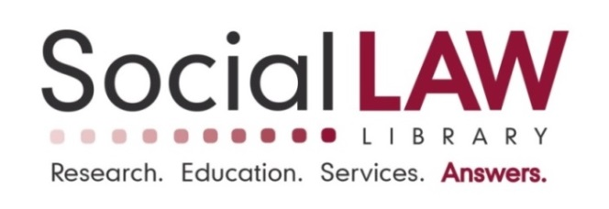

**Notice of Job Openings**

|  |  |
| --- | --- |
| **Potential Job Titles:**  **Hours:** | Reference Librarian/Staff Attorney  The Library is open to a full or part-time candidate |
| **Date Written:** | December 5, 2024 |
| **Immediate Supervisor:** | Director of Library & Member Services |
|  | |

The Social Law Library is excited to announce that we are looking to expand our Reference and legal team!

Located in Boston’s John Adams Courthouse, the Social Law Library is one of the nation’s oldest and most respected legal research institutions. The Library serves all three branches of Massachusetts government, dues-paying members from all segments of the private bar throughout Massachusetts and the U.S., as well as legal-services organizations and law-related nonprofits in every region of the Commonwealth.

Reference staff provide patrons with research advice, materials, training, continuing legal education, and other services. Research is conducted across a variety of practice areas and jurisdictions, and on a typical day involves running case law searches, suggesting specific resources, compiling statutory and regulatory histories, and tracking down case filings and other government documents. We are looking for candidates with outstanding customer-service and interpersonal skills, excellent analytical and problem-solving capabilities, and the ability to exercise confidentiality.

The Library is open-minded with respect to applicants’ educational and employment backgrounds as long as they have the research skills to assist patrons engaged in the practice of law. Candidates with MLIS degrees or J.D.s, those seeking full-time or part-time employment, and those with relevant law library experience at firms or academia are encouraged to apply for an interview.

The Library also welcomes attorneys looking for alternatives to active practice, especially those with strong research and writing skills. Candidates with an interest in advising and assisting with contract analysis, licensing, and negotiations with publishers, HR issues, and other legal matters that periodically arise are encouraged to apply.

The Library is open Monday through Friday, 8am to 4:30pm, and the position could be up to full-time of 35 hours. Flexible scheduling and the potential for hybrid work are available. Specific hours are to be mutually agreed upon with the Director of Library & Member Services.

Salary Range for Full-Time: $75,000 - $85,000 and part-time will be adjusted accordingly

The Library is an eligible employer for the Public Service Loan Forgiveness Program (PSLF)

Benefits for all employees:

Employer contributions to the Library’s Profit-Sharing Plan

Pre-taxed Flexible Spending Accounts

Life Insurance

Short- & Long-Term Disability/MAPFML

Optional Retirement Savings Plans

Paid Sick Days

Full-Time employees receive the above and also the following benefits:

75% Employer-Paid Health Insurance (including deductible reimbursements)

75% Employer-Paid Dental Insurance

Subsidized Commuter Rail or MBTA passes

Paid Vacation, Holiday, and Personal Days

Submit letter of interest and resume to:

Kirsten Leary, Director of Library & Member Services

Social Law Library

John Adams Courthouse

1 Pemberton Square

Boston, MA 02108-1792

Voice (617) 226-1500

[email:joblistings@socialaw.com](mailto:e-mail:joblistings@socialaw.com)